CEC Medication Reconciliation Toolkit
Prioritisation of change ideas template

SMART Aim Statement | Primary Drivers | Secondary Drivers | Change Ideas | Prioritisation of Change Ideas
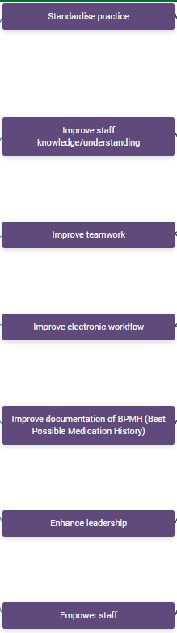  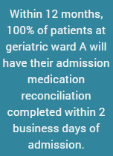 |  | 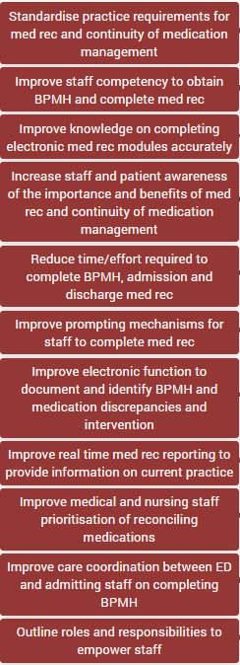 | 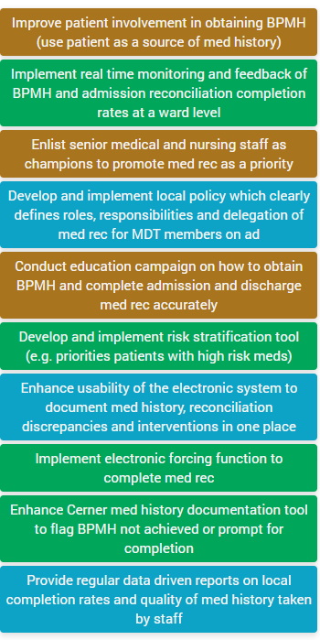  Impact: Medium  Implementation: Medium  Impact: High  Implementation: Hard  Impact: High  Implementation: Hard  Impact: High  Implementation: Hard  Impact: High  Implementation: Medium  Impact: Medium  Implementation: Medium  Impact: High  Implementation: Very Hard  Impact: High  Implementation: Hard  Impact: High  Implementation: Very Hard  Impact: High  Implementation: Hard
Note: This driver diagram (except the prioritisation of change ideas) was created using the Quality Improvement Data System (QIDS).

Copy and paste your driver diagram in this template, display it in front of the text, and manually include your prioritisation in the last column.

